**DESCRIPTION AND SITE MAP**

**This site map shows how every page of the website follows each other when scrolling through.**

1. **Home page (Welcome Page): A page showing the brief of contents to expect in the entire site**

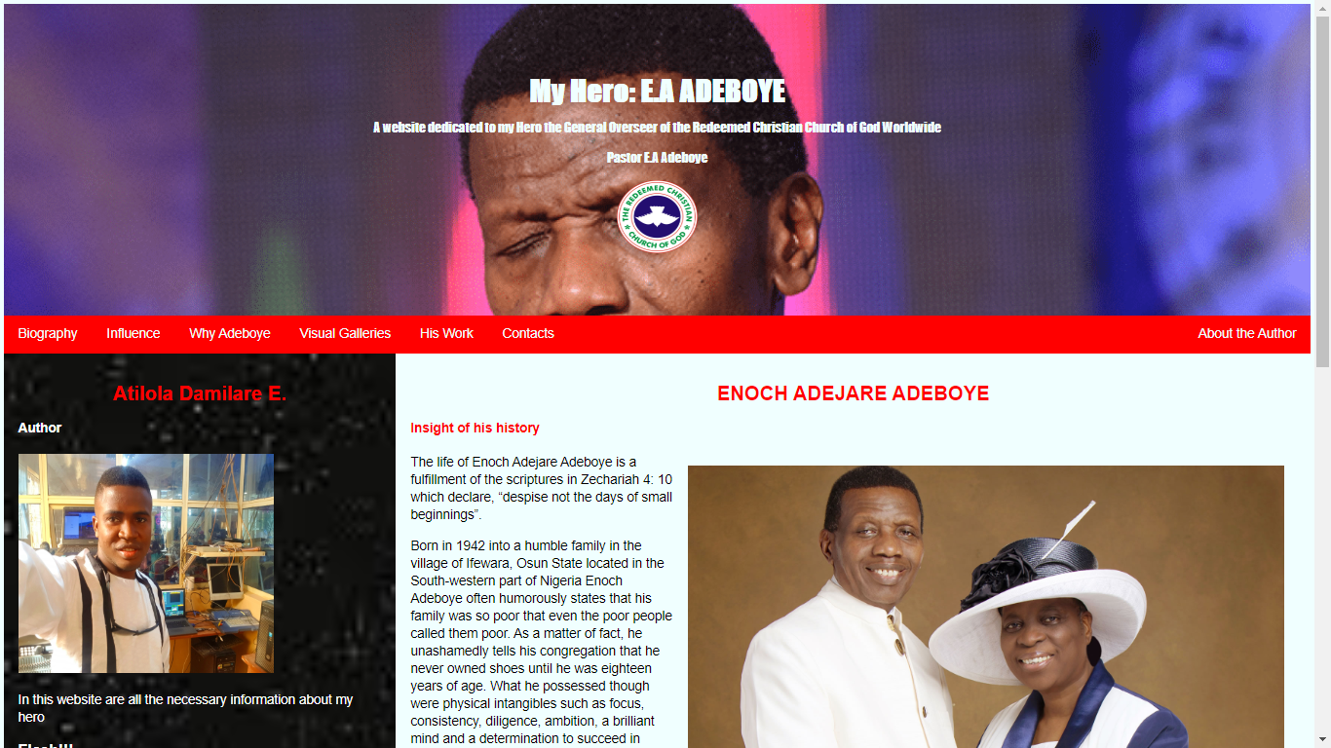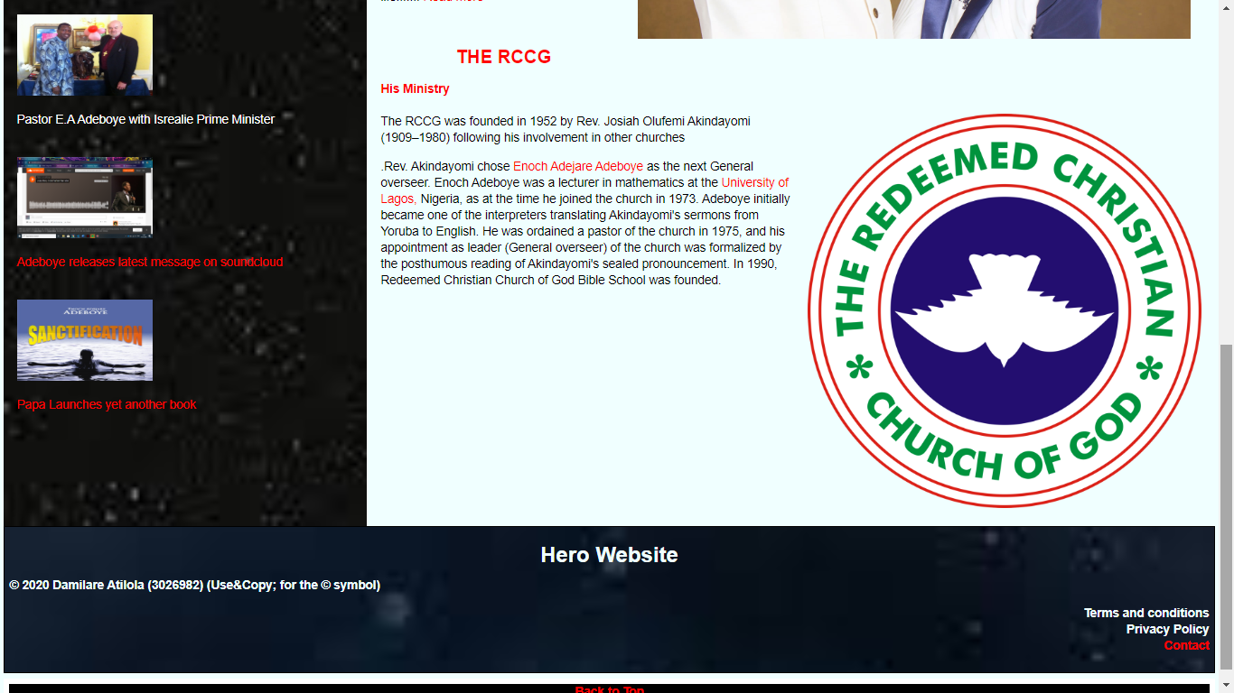

**Welcome Page Leads to the Biography Page and Vice versa.**

1. **Biography Page of my Hero: A page that talks about the background and ministry of my hero.**

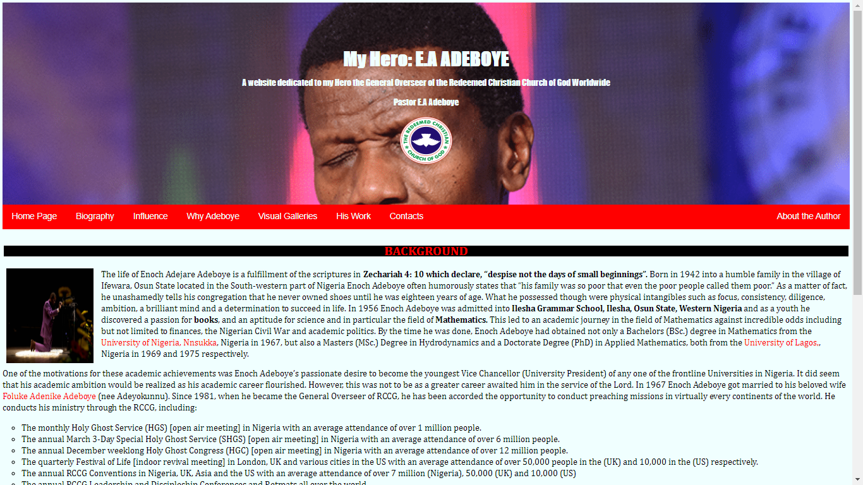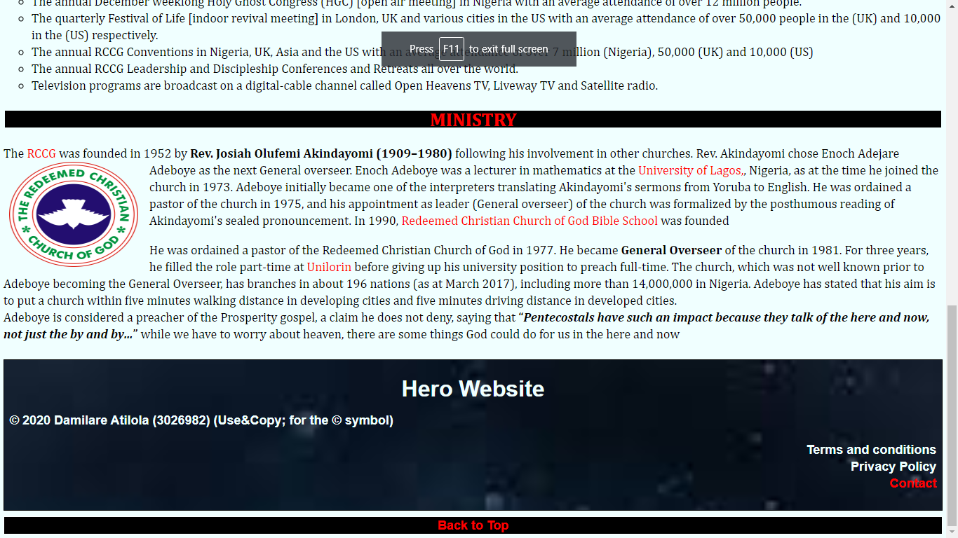

1. **Achievements: A page listing all the achievements and influences my hero have had on people.**

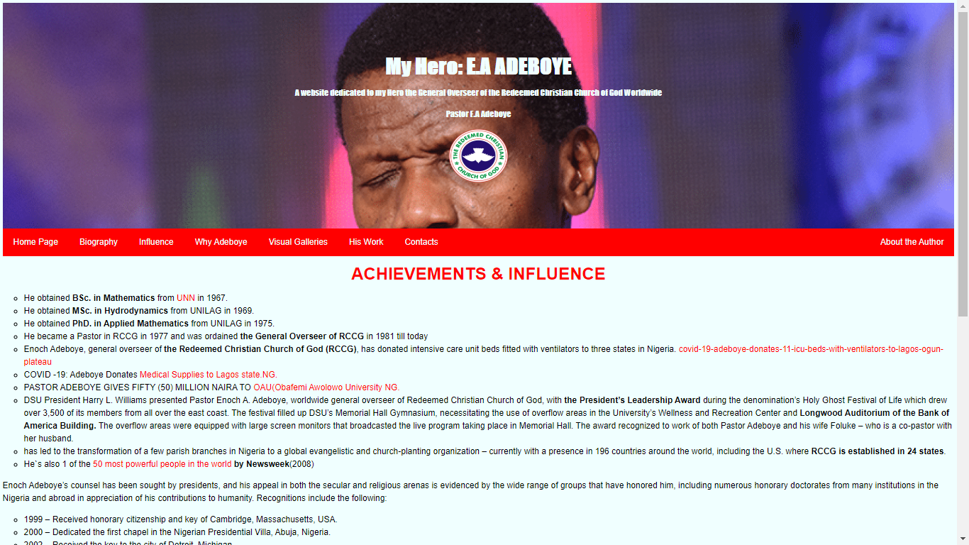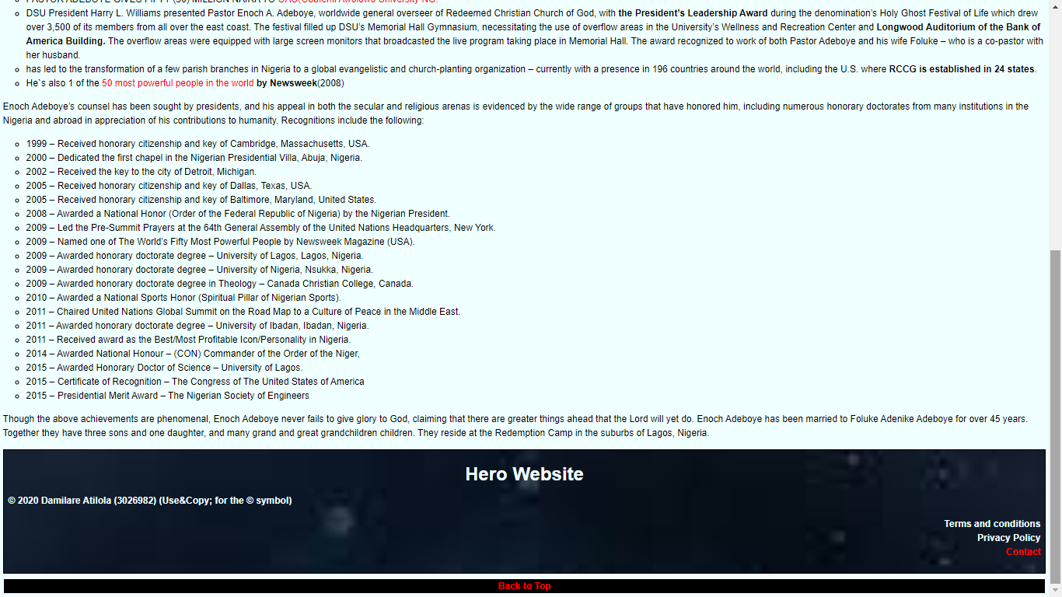

1. **Why Page: A page showing what inspires me to write about my Hero(E.A Adeboye)**

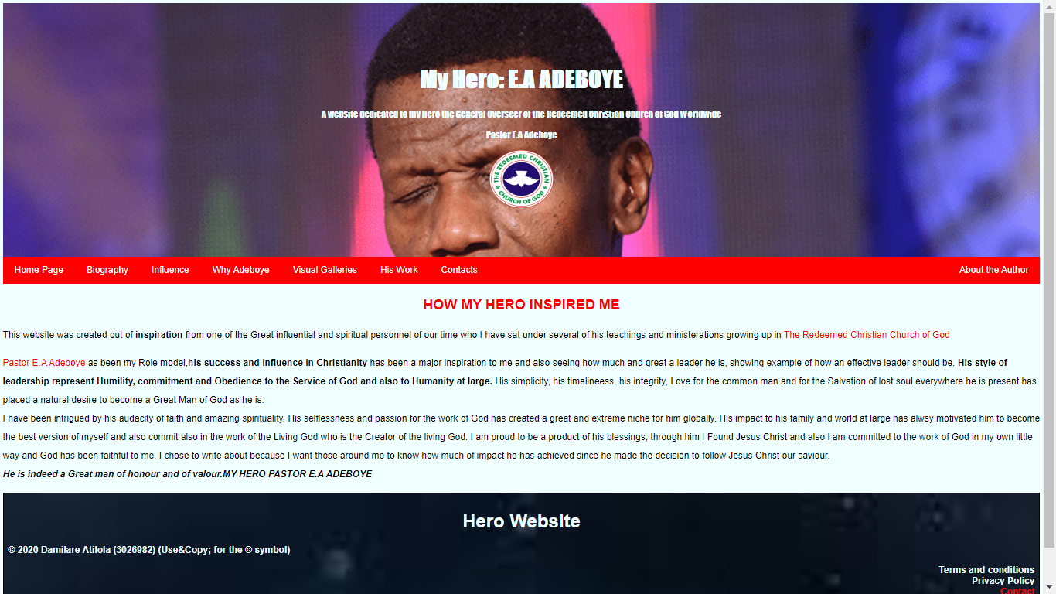

**\**

1. **Galleries page: A page showing some selected pictures of my Hero**

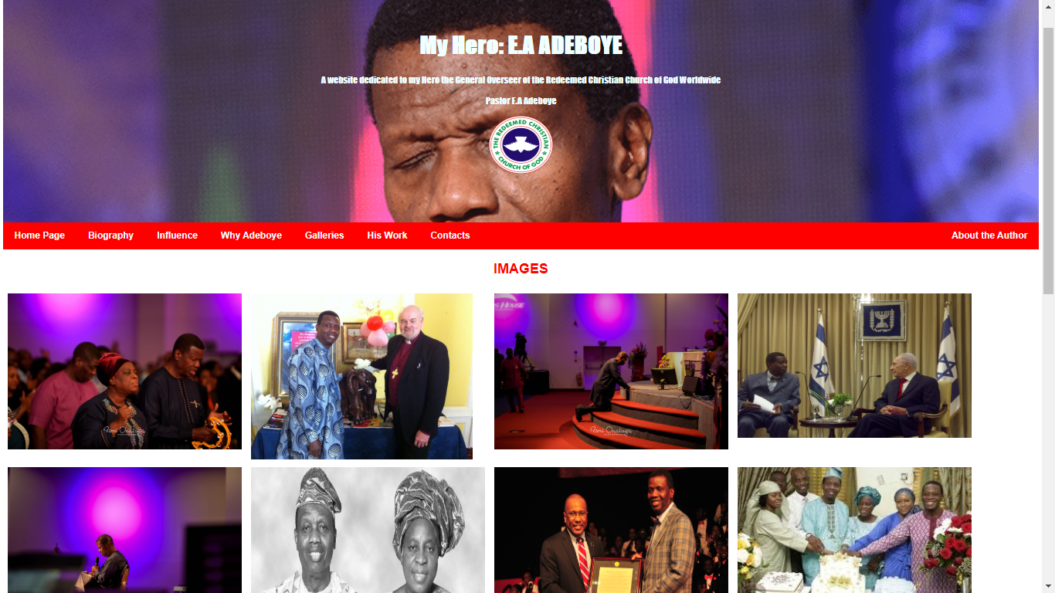

1. **His Work page: A page that illustrates the work of my Hero.**

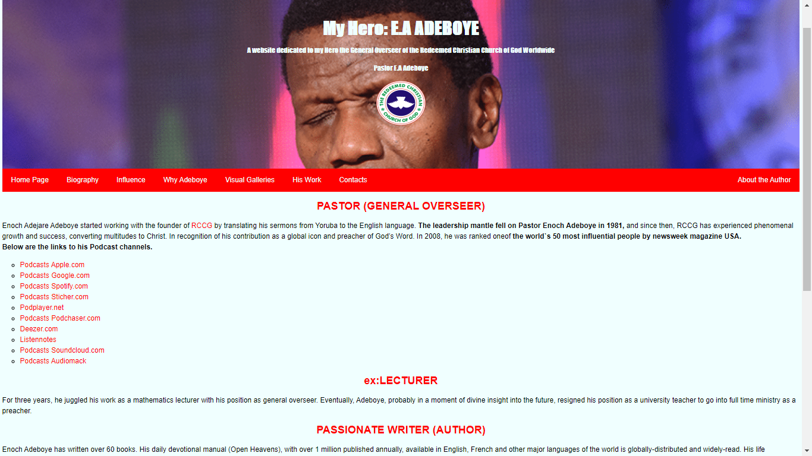

1. **Contact Page: A page that have the contact information of my hero.**

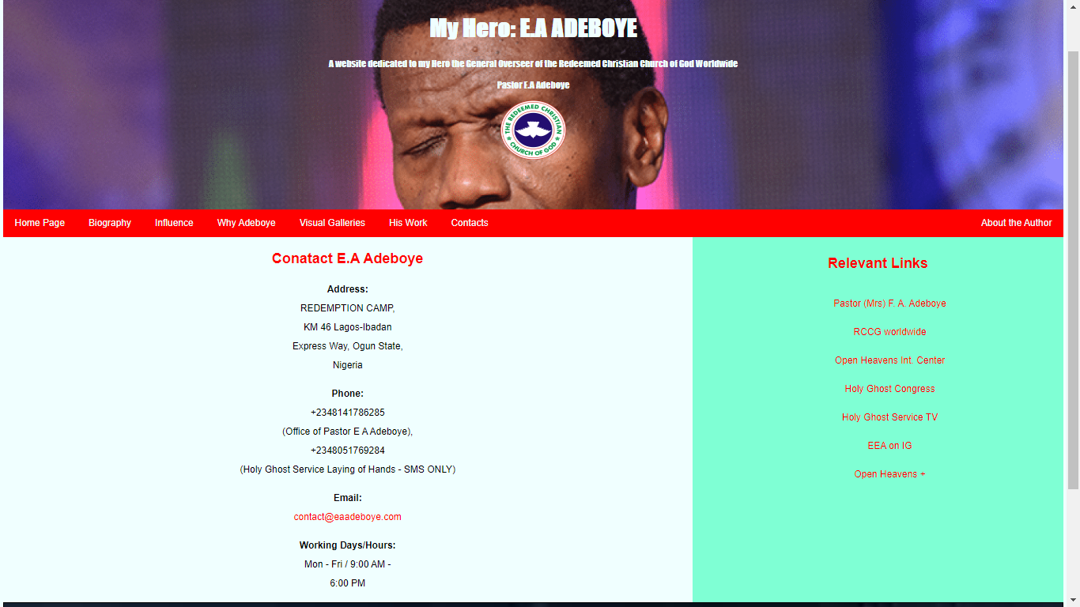

1. **About Page: A page that briefly talk about myself as the Designer of the entire website**

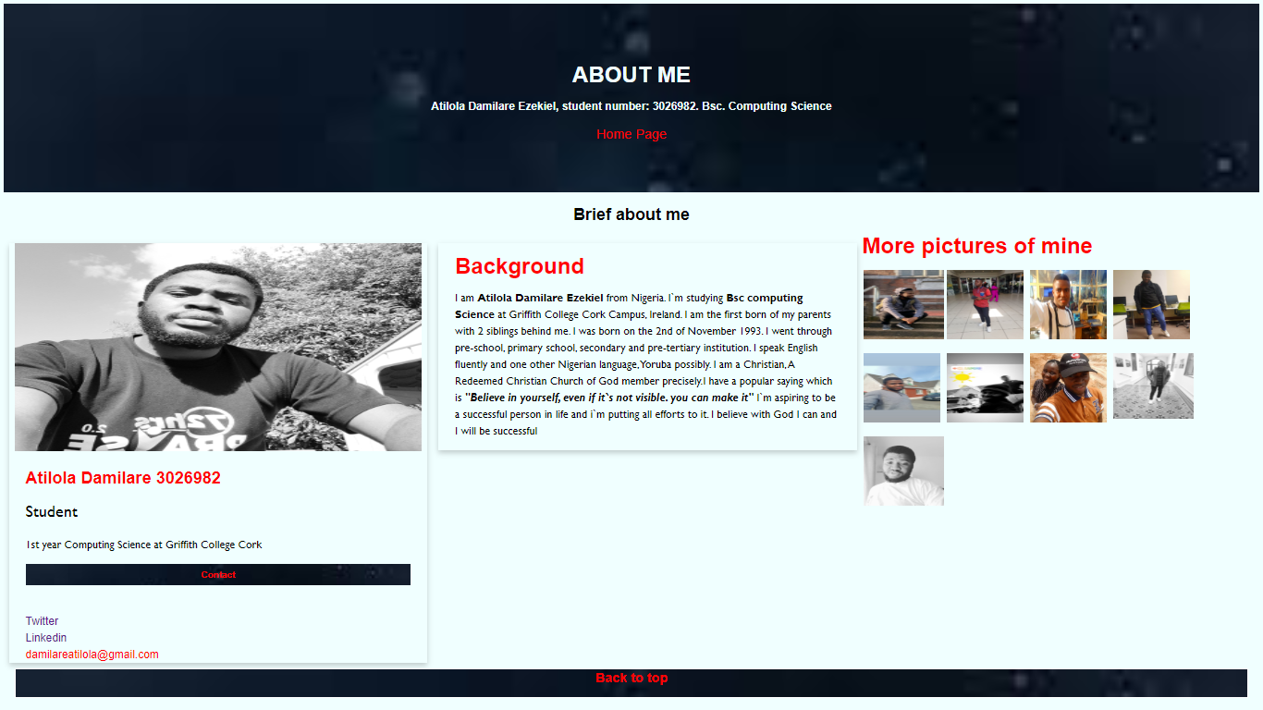

**All Pages Intertwined with exception of About Page that leads Directly back Home Page**